Missouri RTNs
Regional Transition
Networks

STELLAR
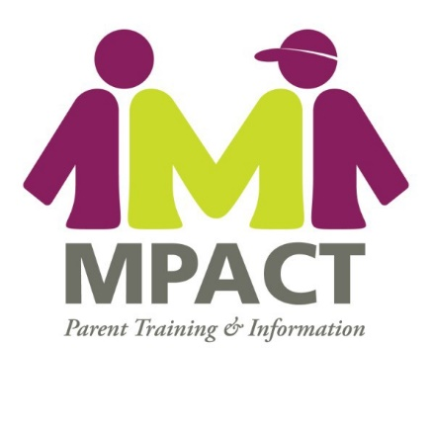
Transition Project
What is an RTN?

An RTN is a Regional Transition Network. Each RTN is made up of community stakeholders in the areas of employment, independent living and education.
- The purpose of an RTN is to develop a local and sustainable group focused on employment and independent living for youth with disabilities.
- Each RTN will create partner- ships in the community that improve employment and independent living options for youth with
disabilities.
Who is on a RTN?
RTN Members may include:
- MPACT Transition Mentors
- Individuals with disabilities
- VR Counselor from area/regional offices
- CIL staff member from area/regional office
- Individuals with disabilities
Other appropriate community members to include might be business community members, school district and regional community agencies representatives.
What will RTNs do?
- Identify current effective practices and community resources and services for transitioning youth.
- Identify barriers and gaps in services related to employment for people with disabilities.
- Create action plans for addressing the barriers and gaps.
- Work toward alleviating barriers and gaps in services through information, resources and training.
- Disseminate information about employment options and best practices in the region to families, youth with disabilities, and agencies.
When should RTNs meet?
- Meet as a group as soon as possible following identification of initial members.
- Share a snack/beverage
- Get to know one another and your roles in assisting youth and young adults with transition in your region
- Review the purpose of the RTN:
  - To develop a local and sustainable group focused on employment and independent living issues for youth with disabilities
  - Determine a group facilitator and a note taker
  - Identify any missing “links” and discuss strategies to include their representation in the RTN
  - Discuss transition resources in your community—the GOOD as well as gaps/barriers/your experiences
  - Keep the discussion positive
  - Determine a date for your next meet- ing—when you will go through process of determining gaps and barriers and creating an action plan to address them
Identifying Barriers/Gaps
- Have a discussion
- Document the issues that arise—good, bad, and otherwise
- Consolidate categories as necessary
- Prioritize using sticky notes to vote
How about some assistance?

- Transition Resources and Online Trainings can be found on MPACT’s website at www.missouriparentsact.org on the Transition pages and the online training pages.

Contact: Carrie Ragsdale
cragsdale@missouriparentsact.org
Phone: 417-423-7695
The creation of Regional Transition Networks by MPACT Transition Mentors is an activity provided through Project STELLAR Project (Supporting Transition to Engaged Lives by Linking Agency Resources) STELLAR focuses on family involvement across school and adult service community systems. The project provides training and information about planning for the transition to postsecondary adult life to enable individuals with disabilities and their families to interact effectively with professionals from educational, vocational rehabilitation, and independent living systems.
7421 Mexico Road, Suite 200
St. Peters MO 63376
Phone (TTY): (800) 743-7634
Fax: (816) 531-4777
Email: info@missouriparents.act

