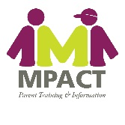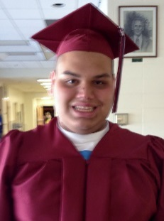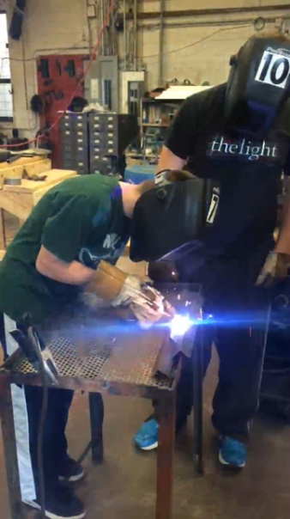

Project **STELLAR**

**Supporting Transition to**

**Engaged Lives by**

**Linking Agency Resources**

The goal of the STELLAR (Supporting Transition to Engaged Lives by Linking Agency Resources) project is to provide information and training to assist transition age youth (14-26) with disabilities, their parents, family members, guardians, advocates, or other authorized representatives of the individual to participate more effectively with professionals in meeting the vocational, independent living, and rehabilitation needs of individuals with disabilities.

**Innovative approaches to this initiative include:**

Transition Mentors statewide to provide direct assistance to youth with disabilities and their families on transition issues and available services.

Statewide Region Transition Networks (RTN) who will create ways to deliver on-going training and information to enable individuals with disabilities, parents, family members, guardians, advocates, or other authorized representatives of the individual to participate more effectively with professionals in meeting the vocational, independent living, and rehabilitation needs of the individuals with disabilities, particularly those who are members of populations that have been unserved or underserved.

Each RTN will develop a strategic action plan to address training and information dissemination for the transition services needs of youth with disabilities and their family members that were previously unserved or underserved.

Each RTN will increase collaboration with school districts to more effectively partner with employers to gain work experience for youth with disabilities while still in high school.

RTNs will disseminate information and resources to transition age youth with disabilities, family members, service providers, school districts, and community members statewide on all key components of transition to adult life and the work of the RTNs.

**Some of the strategies that the STELLAR project will focus on are:**

* Career focused and on-the-job training while in school
* Inclusion of self-advocacy and self-determination skills in the curriculum
* Interpersonal skills, and job-related skills training for students
* Supervised on-the-job training in the community with continuous support for both the employer and the student
* Involvement of students, parents, businesses, and community representatives in interagency transition teams
* Meaningful job placement experiences that provide living wages and career opportunities for youth with disabilities
* Coordination between school and post-school activities

For more information about STELLAR contact 800-743-7634 or cragsdale@missouriparentsact.org