RAISE Summit 2018
Presenter Bios
Tami Allen
Tami Allen is the Program Director for the Families Together Inc./Family to Family Health Center. She has had over 25 years of experience working with Families Together as a voice for children and youth with special health care needs.
Tami and her husband Terry have a combined family of 8 children. Their son Skylar is 36 and is young adult with special health care needs including cerebral palsy. Tami has been instrumental in the development of his health care plan and independent living services to better support his endeavor in self-directing his life and needed services as well as living and working independently. Among Tami’s areas of expertise is transition from school to adult services, employment and Independent Living, advocacy and policy making, and parent and family supports within the community.
Tami serves a number of advisory boards including: The State Independent Living Council of Kansas, Kansas Assistive Technology Advisory Board, Living Independently in Northwest Kansas Board, Community Health Coalition, Southwest Developmental Services Board and Mosaic Human Rights Council.

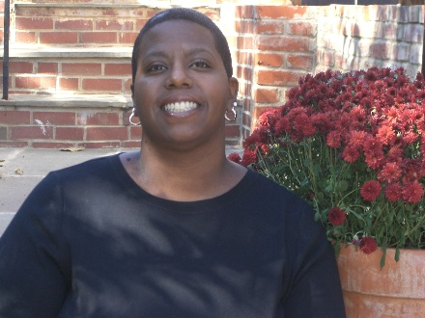
Dara Baldwin
Before joining NDRN in June 2014, Dara was an ADA Compliance Specialist in the DC Government and also served as a policy analyst at the National Council on Independent Living (NCIL). She was responsible for the diversity and cultural competency outreach as well as working on coalitions to assist with better legislative outcomes for the community. She uses the social justice concept created by Kimberlé Crenshaw – titled Intersectionality in all of her public policy work. She has led multiple national and international advocacy campaigns
She assisted with writing the disability provisions and was a leader in the advocacy campaign to get the Violence Against Women Act of 2013 passed in February 2013. Ms. Baldwin worked on 13 bills that passed in Congress and were signed by President Barak Obama during his term in office. She worked as a Child Advocate in NJ, Sr. Policy Analyst on multiple criminal justice issues such as the Second Chance Act and as an Advocacy Manager at TASH. She is highly skilled in social media outreach and advocacy.
Dara Baldwin was born in Spain and raised in Newark, NJ. She has a Bachelor of Arts in Political Science from Rutgers University, Newark, NJ and was a Pi Alpha Alpha honors Graduate with a Masters of Public Administration from Rutgers University the School of Public Affairs and Administration, Newark, NJ. She received a 2009 and 2010 Presidential Citation Award for her work in the American Society for Public Administration (ASPA).
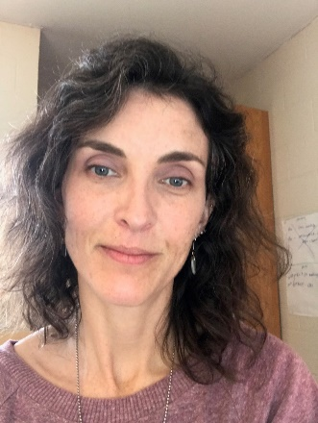
Judith Gross
Judith Gross is the Director of the Center on Community Living and Careers at the Indiana Institute on Disability and Community at Indiana University. She has over 20 years of experience as a special education teacher, direct service provider, advocate, researcher and technical assistance provider. Her research has primarily focused on promoting high expectations for employment of people with disabilities and supporting individuals and their families to access and use available resources and benefits to promote competitive employment and community participation. Gross is author and co-author of numerous journal articles, book chapters, and white papers/reports focused on family-community-school partnerships, employment and community living for people with disabilities, and engaging culturally diverse families in school and, more specifically, the IEP and transition to adulthood processes.

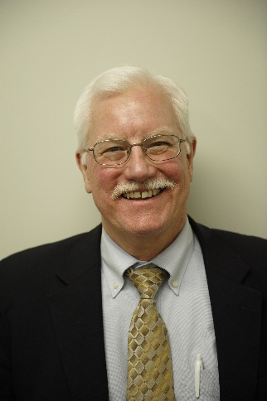
Ron Hager
Ron Hager is a Senior Staff Attorney at the National Disability Rights Network in Washington, DC. Ron provides training and technical assistance to the P&A/CAP network on special education and assists in overseeing training and technical assistance to CAP. He has specialized in disability law, particularly special education, since 1979, when he started his legal career in Buffalo as a VISTA attorney. After that, he was a Clinical Professor at the State University of New York at Buffalo Law School for nine years, supervising the Education Law Clinic. In 1991, Ron moved to Neighborhood Legal Services (NLS) where he represented clients in a wide variety of disability-related cases. As part of NLS's National AT Advocacy Project, Ron also was a frequent author on disability-law-related issues. He was co-chair of the New York State Bar Association's Committee on the Rights of People with Disabilities for four years, and was the President of the Board of Directors of Autistic Services, Inc., in Western New York, for 10 years. Ron earned a B.A. in Psychology from the State University of New York at Binghamton and a J.D. from the State University of New York at Buffalo Law School.

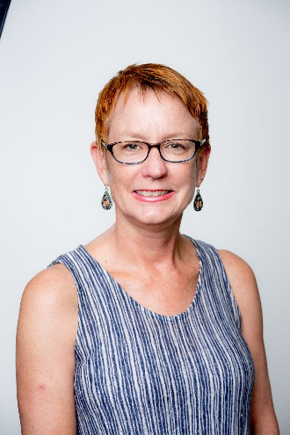
Dianne Malley
Dianne is the Project Director, Transition Pathways, A. J. Drexel Autism Institute, Drexel University. Transition Pathways, an initiative of the Life Course Outcomes, at the A.J. Drexel Autism Institute, is a collection of innovative efforts to improve outcomes for young adults on the autism spectrum. As Project Director, Dianne is passionate about building and strengthening strategic partnerships to develop innovative solutions to address the needs of young adults with autism. She has extensive experience in nonprofit leadership and has led numerous initiatives to convene partnerships to expand capacity to effectively support youth with autism to transition to adulthood. She received a Master of Fine Arts from the State University of New York at Buffalo and has completed a Certificate in Nonprofit Management from the Nonprofit Center at La Salle University’s School of Business. Dianne is the mother of three daughters. As a parent of a young adult with a developmental disability, she has direct experience with the multiple systems that impact youth with disabilities and their families.

Susan Richmond
Susan Richmond is a consultant at the Center for Autism and Related Disabilities at USF and the Coordinator of the Learning Academy at USF and the Learning Academy Employment Services. Beginning her career in a state developmental center for people with intellectual disabilities, she has over thirty years of experience in the field of disabilities. Susan has a Bachelor's degree in Social Work and a Masters in Education. She served as the Deputy Director of the NJ Council on Developmental Disabilities for twenty years where she participated in numerous advocacy and policy related activities aimed at improving the quality of life for individuals with disabilities. In her current positions at USF Susan enjoys working directly with individuals, their families and the professionals that serve them helping to improve their skills and provide necessary resources to increase their ability to succeed in life.

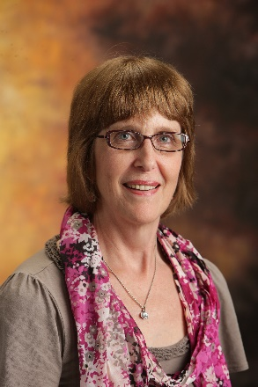
Connie Zienkewicz
Connie has been the Executive Director of Families Together, Inc., the Parent Training and Information Center for Kansas since May of 1997. Families Together, Inc. provides training and support for families across Kansas who have a son or daughter with disabilities. Connie and her husband have six children. They have a daughter, Julie, with exceptional needs. Julie is 32, enjoys music, interactions with others, uses a wheel chair for mobility, and communicates non-verbally. Currently Julie lives in Shared Living and attends an Adult Day Program.

Connie Zienkewicz has expertise in the following areas:
- Training of Parents and Professionals regarding laws protecting the rights of children with disabilities in the educational system
- Special Education and Related Services
- Section 504 of the Rehabilitation Act
- Post High School Transition
- Early Childhood Transition
- Evaluation and Alternate Assessment
- Advocacy and Policy Making
- Parent and Family Supports in the Community
Connie has received training in the following areas:
- Grant Writing
- Capacity Building for School Districts
- Corporate Funding: Opportunities for Nonprofits
- Managing Employees
- Criticism and Discipline Skills for Managers
- Individuals with Disabilities Education Act 2004
- Section 504 of the Rehabilitation Act

